1. Create one VPC,with 1 one public subnet and 1 private subnet.

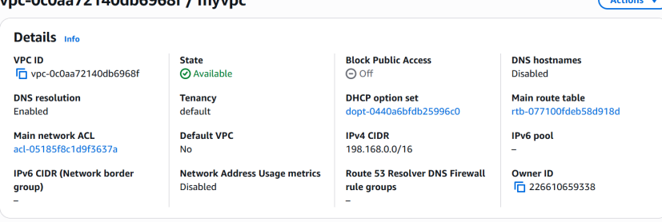

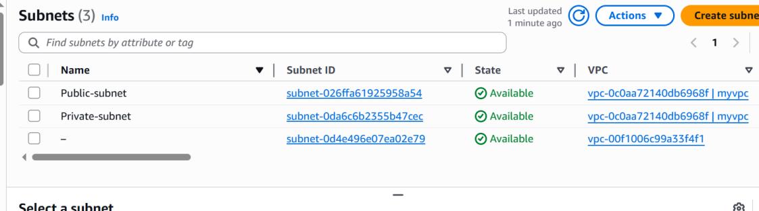

1. Enable VPC peering for cross region.

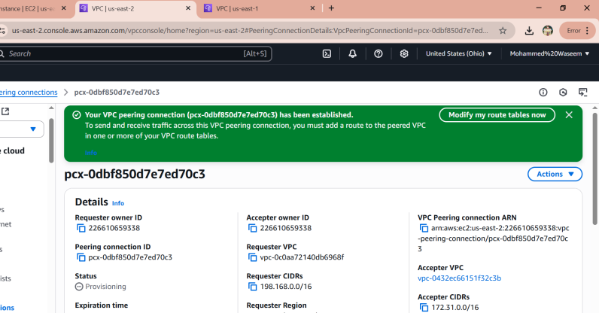

1. Enable VPC peering for cross account. (You can collaborate with your friend and do this task).

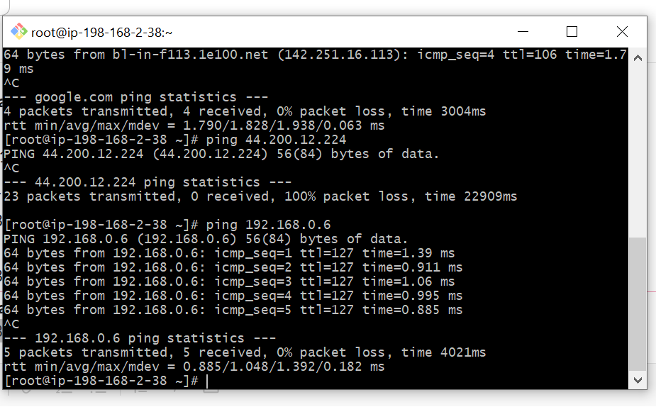

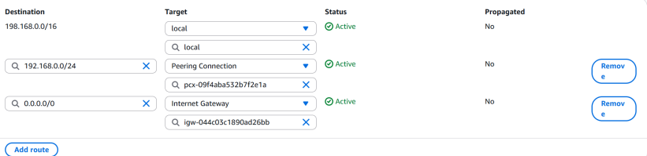

1. Setup VPC Transist gateway.

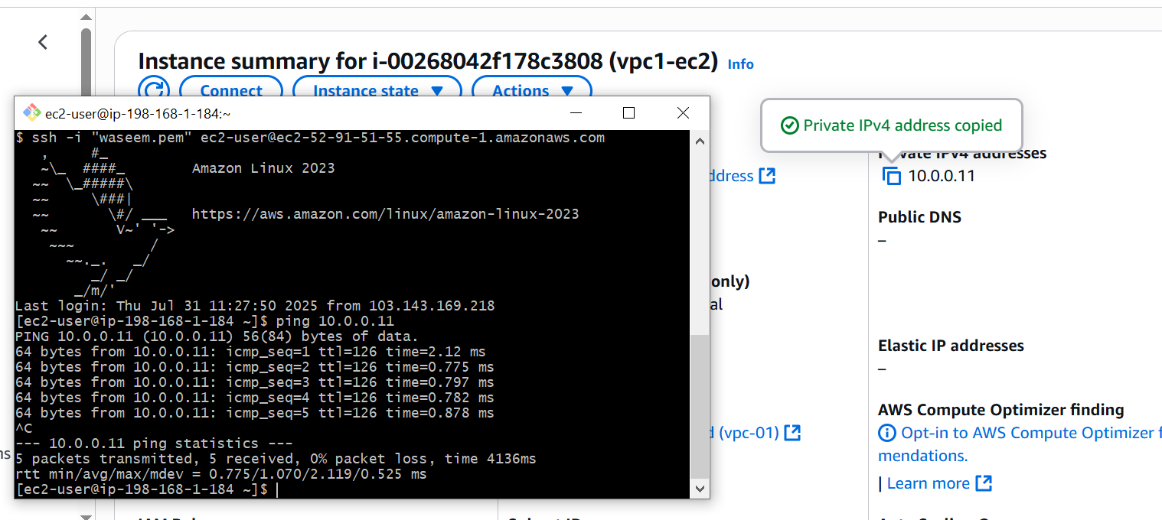

In above default to vpc1 (10.0.0.11) is attached

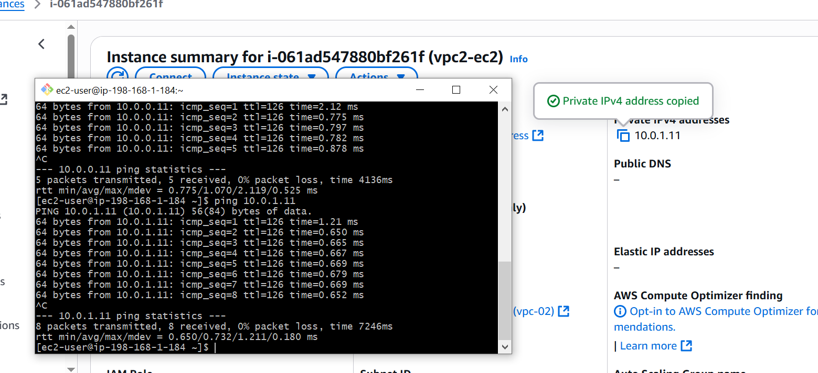

In above default to vpc2 (10.0.1.11) is attached

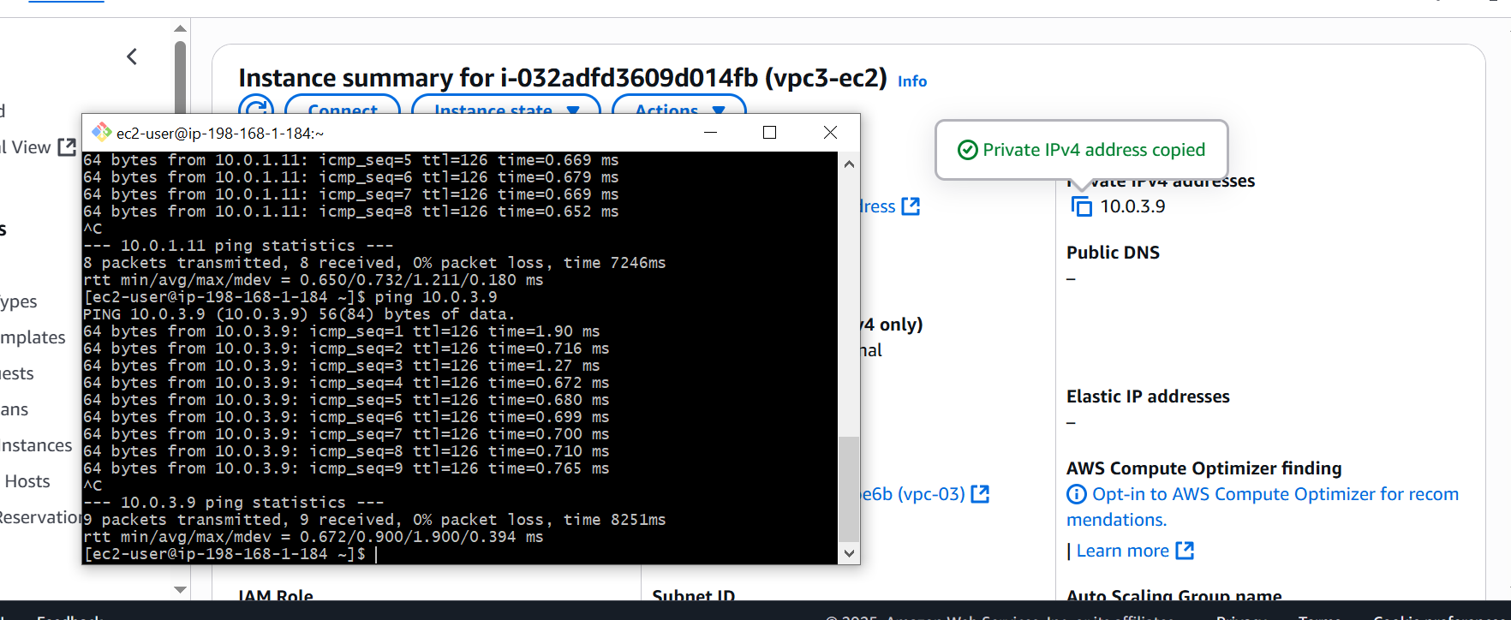

In above default to vpc3 (10.0.3.9) is attached

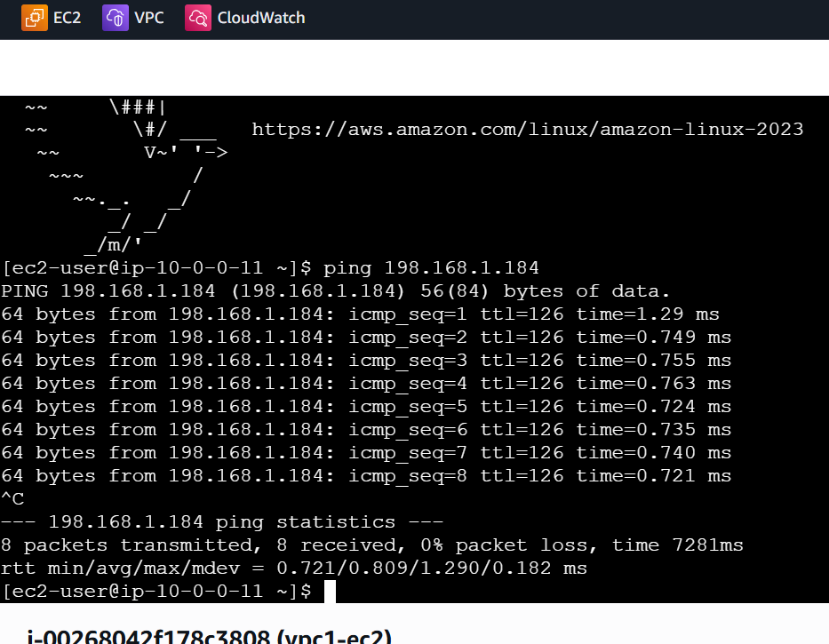

In above we have connected from vpc1 (10.0.0.11) to default

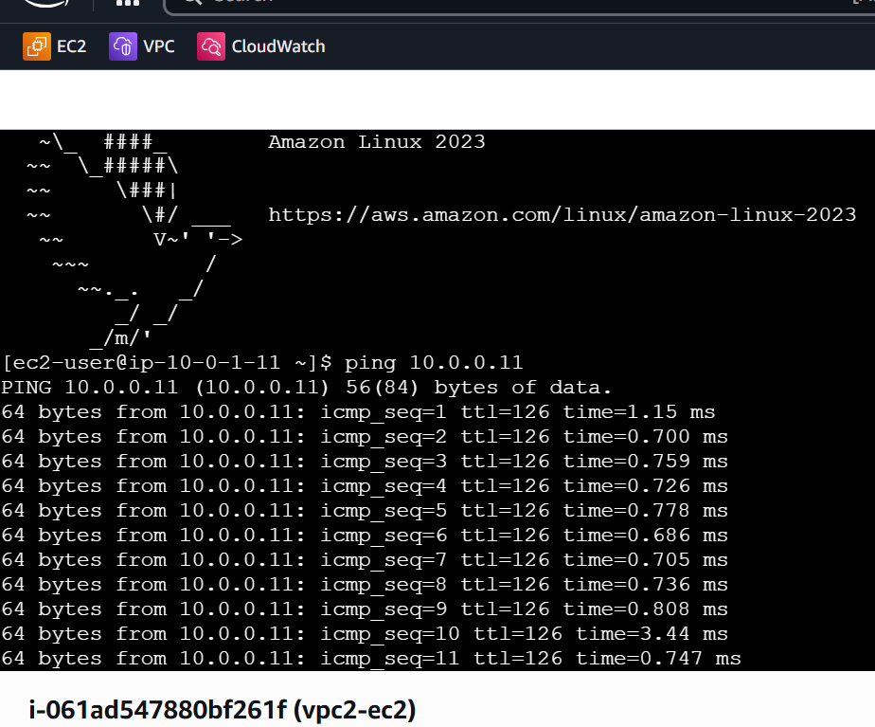

In above we have connected from vpc2 (10.0.1.11) to vpc1 (10.0.0.11)

1. Setup VPC End Point

